**Project 2**

Title

**Random Number Guessing Game**

Course

**CSC 5**

Section

**44188**

Due Date

**April 17th, 2017**

Author

**Zachary Miller**

**Introduction**

Title: Random Number Guessing Game

This is a logic based game.

The objective of the game is to guess a random number that is generated by the computer in the allotted amount of guesses.

**Pseudocode**

/*

* File: main.cpp

* Author: Zachary Miller

* Purpose: Create a random number guessing game. The game will allow the user

* to customize the difficulty of the game by increasing the range at which

* the random number generator will pick between and lowering the

* amount of guesses you are allowed before the game ends.

*

* Minimum range of numbers is 10

* Minimum number of guesses is 5

*

*/

//System Libraries

//Declare Variables

//Prompt user for range of numbers

//Input validation checking number range

//Seeding random number

//Generate random number for answer

//Prompt user for number of attempts

//Input validation checking for valid attempts

//For loop to iterate each attempt

//If-Else to to check if the guess is not equal to answer or if the guess was correct

//Nested if-else if guess was too high or too low and display result of guess if wrong

//Compound number of attempts against actually attempts

//If statement to test if user runs out of attempts to end the game

//Output correct answer and thank user for playing

**Flowchart**

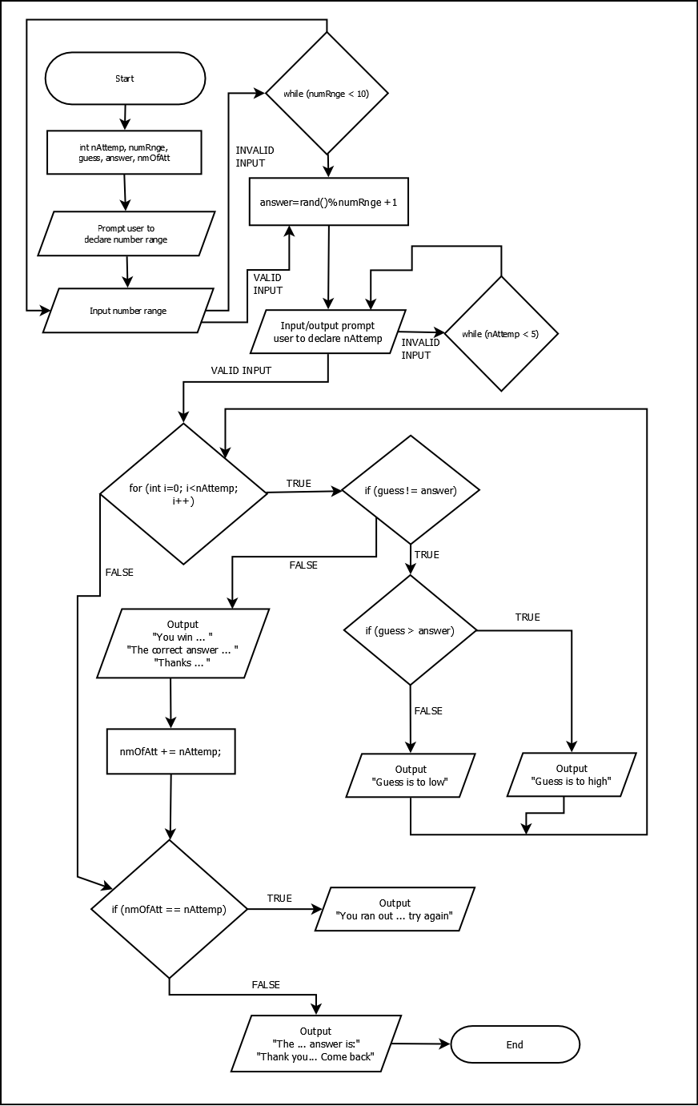

**Program**

/*

* File: main.cpp

* Author: Zachary Miller

* Purpose: Create a random number guessing game. The game will allow the user

* customize the difficulty of the game by increasing the range at which

* the random number generator will pick between and lowering the amount

* of guesses you are allowed before the game ends.

*

* Minimum range of numbers is 10

* Minimum number of guesses is 5

* Created on April 7, 2017, 2:10 AM

*/

#include <iostream>

#include <cstdlib>

using namespace std;

int main(int argc, char** argv) {

int nAttemp = 0; //Number of attempts to get the correct answer

int numRnge = 0; //Number range

int guess = 0; //Guess variable

int answer = 0; //Store the random answer

int nmOfAtt = 0; //Variable used to test whether you were out of attempts to display a message

//Prompt user for the range of numbers

cout << "This is a random number guessing game.\n";

cout << "I, the computer, will randomly pick a number\n\n";

cout << "You will have a set amount of attempts to try and guess it. But, don't worry, I'll be giving you clues along the way\n\n";

cout << "First, what is the range of numbers you want the number to be between?\n";

cout << "Only type in one number, for example, if you want to guess a number between 1 and 10, you'll enter 10\n";

cout << "or you want to try to guess a number between 1 and 100, you will enter 100 when prompted\n\n";

cout << "So go ahead, enter the range for the number to be between.\n";

cin >> numRnge;

cout << "\n";

//Input validation for number range

while (numRnge < 10) {

cout << "You didn't enter a valid range." << endl;

cout << "Input must be greater than or equal to 10." << endl;

cout << "Please re-enter a valid range: ";

cin >> numRnge;

cout << endl;

}

srand(time(NULL)); //seeding random number

answer = rand() % numRnge + 1; //assigns random number to answer variable

//Asking user to input the amount of attempts he/she wants

cout << "Now, how many attempts would you like to have to guess the number?" << endl;

cin >> nAttemp;

cout << endl;

//Input validation for attempts

while (nAttemp < 5) {

cout << "You didn't enter a valid number of attempts." << endl;

cout << "Attempts must be greater than or equal to 1." << endl;

cout << "Please re-enter a valid number of attempts: ";\

cin >> nAttemp;

cout << endl;

}

//Loop for the number of guesses allowed

for (int i = 0; i < nAttemp; i++) {

cout << "Guess #" << i + 1 << ": ";

cin >> guess;

//If else statement to test if guess is correct or false

if (guess != answer) {

//Nested if else statement to output if guess was to high or low

if(guess > answer) {

cout << "Guess is too high. Try again.\n\n";

} else {

cout << "Guess is too low. Try again\n\n";

}

} else {

cout << "You won!\n";

cout << "The correct answer is: " << answer << "\n\n";

cout << "Thank you for playing my game. Come back real soon!\n";

return 0;

}

}

nmOfAtt += nAttemp;

//If to check if you ran out of attempts and display a message

if (nmOfAtt == nAttemp) {

cout << "you ran out of attempts, try again!" << endl;

}

cout << "The correct answer is: " << answer << "\n\n";

cout << "Thank you for playing my game. Come back real soon!\n";

return 0;

}